
Four Well-Established Chem Dry Franchises
Serving Central North Carolina
$350,000 List Price

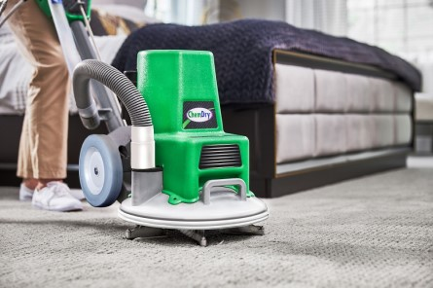

Annual Sales: $350,000 Annual Cash Flow: $100,000

Four well-established very successful Chem Dry franchises serving Wake, Orange, Durham, and Hillsborough counties generating strong annual cash flows focusing on excellent customer service, top quality, and affordable pricing. During it’s 30 year history business has developed an outstanding reputation. Experienced employee team. Mobile cleaning systems and vans included. Seller is retiring and will consider limited seller financing. Franchise territories provide excellent growth opportunities. For more information please contact:

Oak Capital Advisors
8801 Fast Park Drive Suite 301
Raleigh, NC 27617
tom@oakcapitaladvisors.net (919) 452-2788
www.oakcapitaladvisors.net

