
Well-Established Offset and Digital Print Company
$1.75 Million List Price

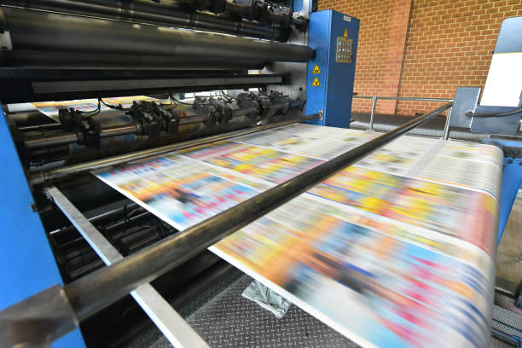

Annual Sales: $1.6 Million Annual Cash Flow: $.4 Million

Well-established very successful offset and digital print company servicing a variety of customers both in central North Carolina and also nationally. Company prints a variety of products, including traditional offset high volume documents, vinyl banners, plastic signs, and traditional business products, such as business cards, letterhead, invoices, brochures, etc. Customer base includes both direct and private branding clients. Company is known for excellent customer service and quick turnaround of orders. Facilities include a manufacturing location and a nearby warehouse. Area and facility combine to provide excellent growth opportunities. For more information please contact:

Oak Capital Advisors
9221 Club Hill Drive
Raleigh, NC 27617
tom@oakcapitaladvisors.net (919) 452-2788
www.oakcapitaladvisors.net

